DAY12

Class Exercise 2

    @PostMapping("/student")

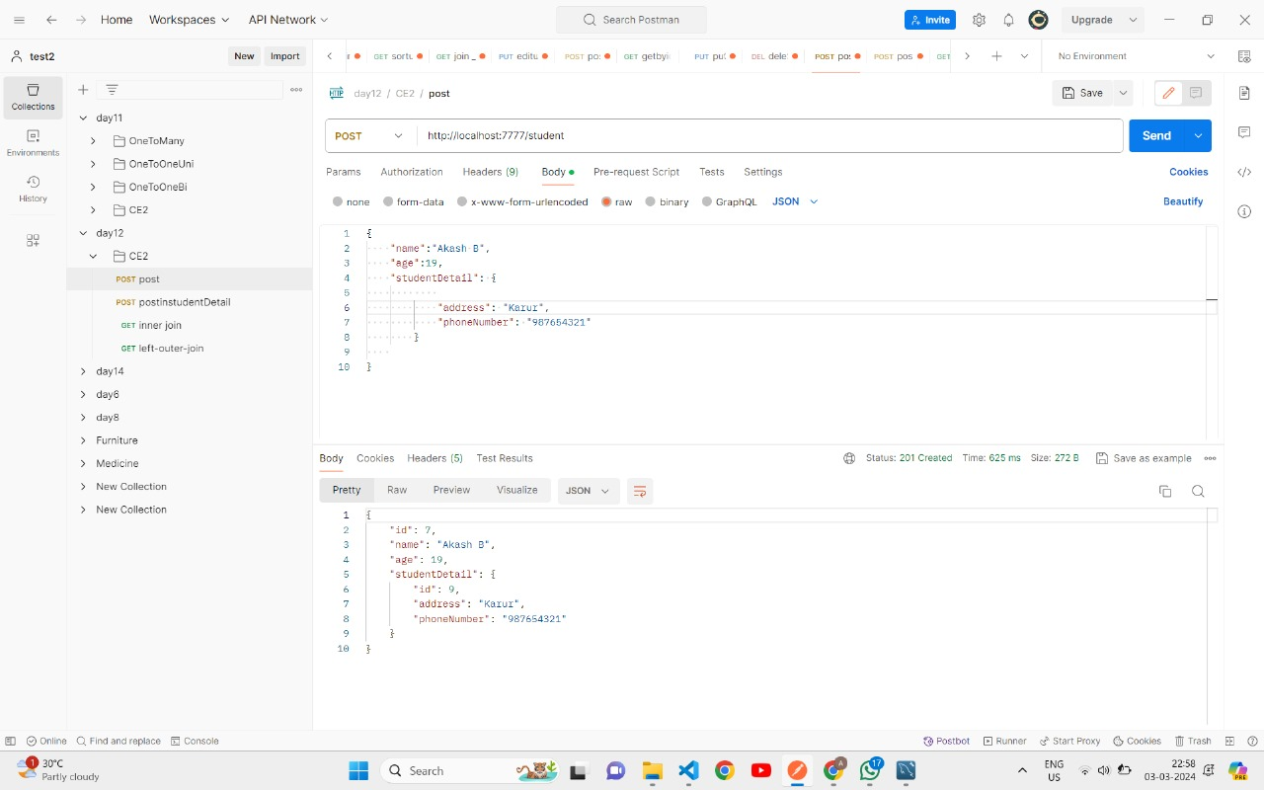

    @GetMapping("/students-inner-join")

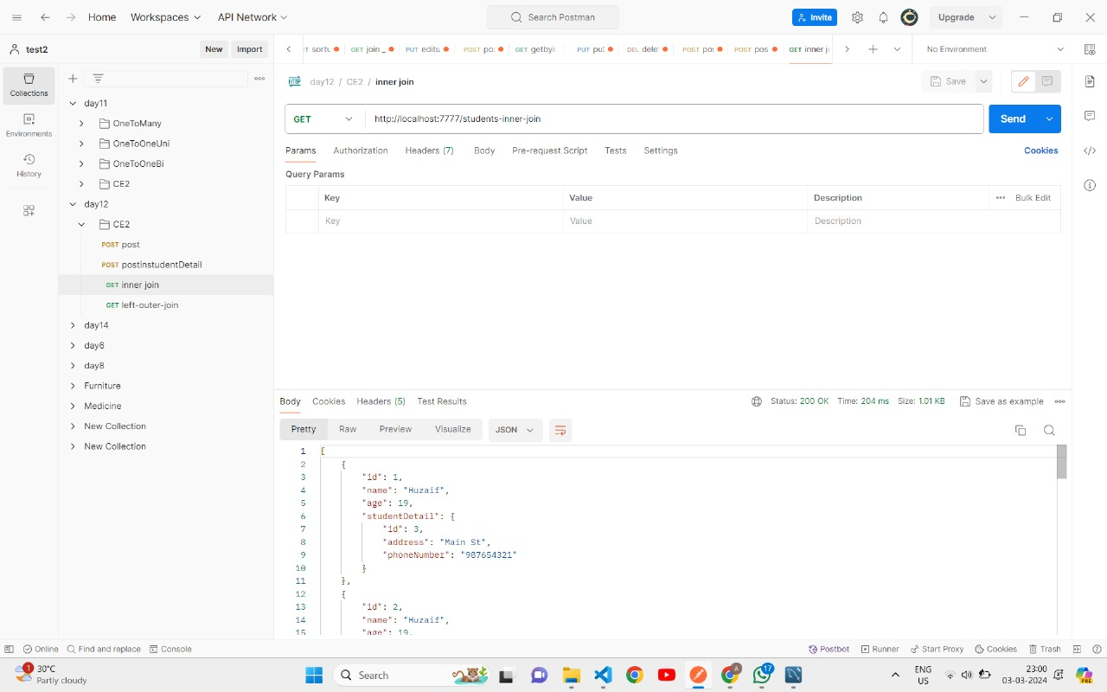

    @GetMapping("/students-left-outer-join")

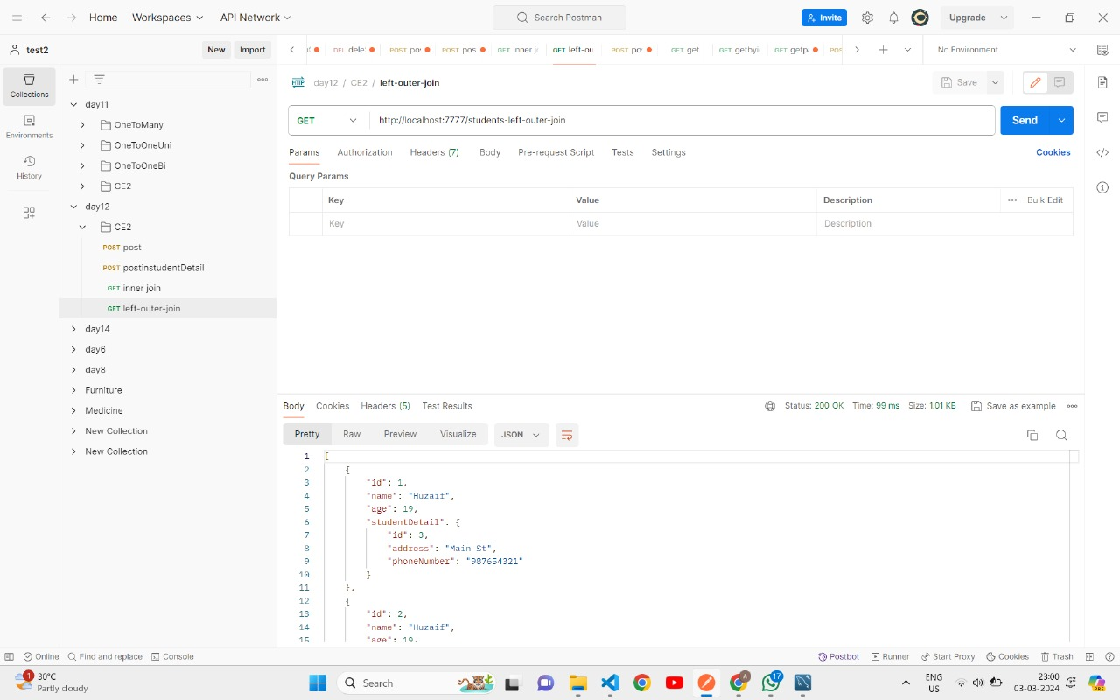

    @PostMapping("/studentDetail/student/{id}")

